**Ex 20-1 #’s 1-3:**

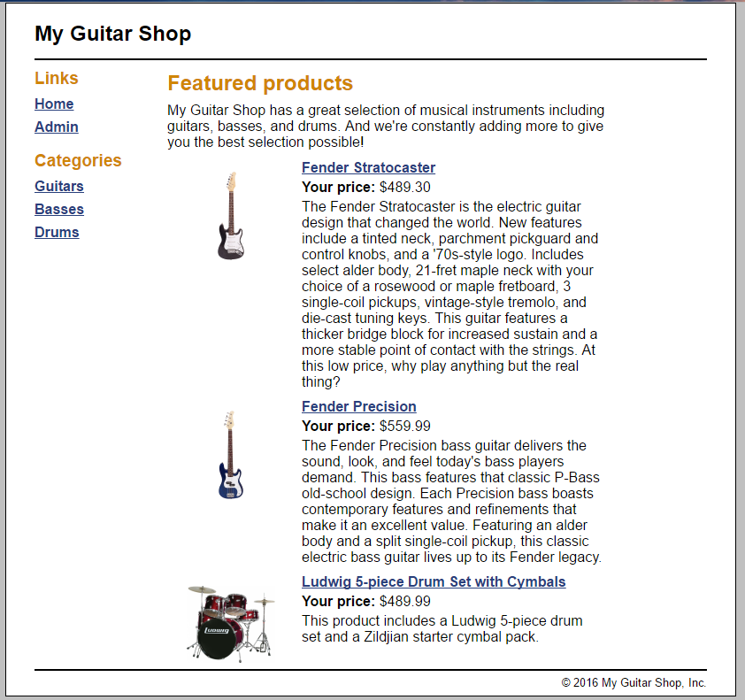

*Able to run the website successful, and use the web application.*

**Ex 20-1 #4:**

*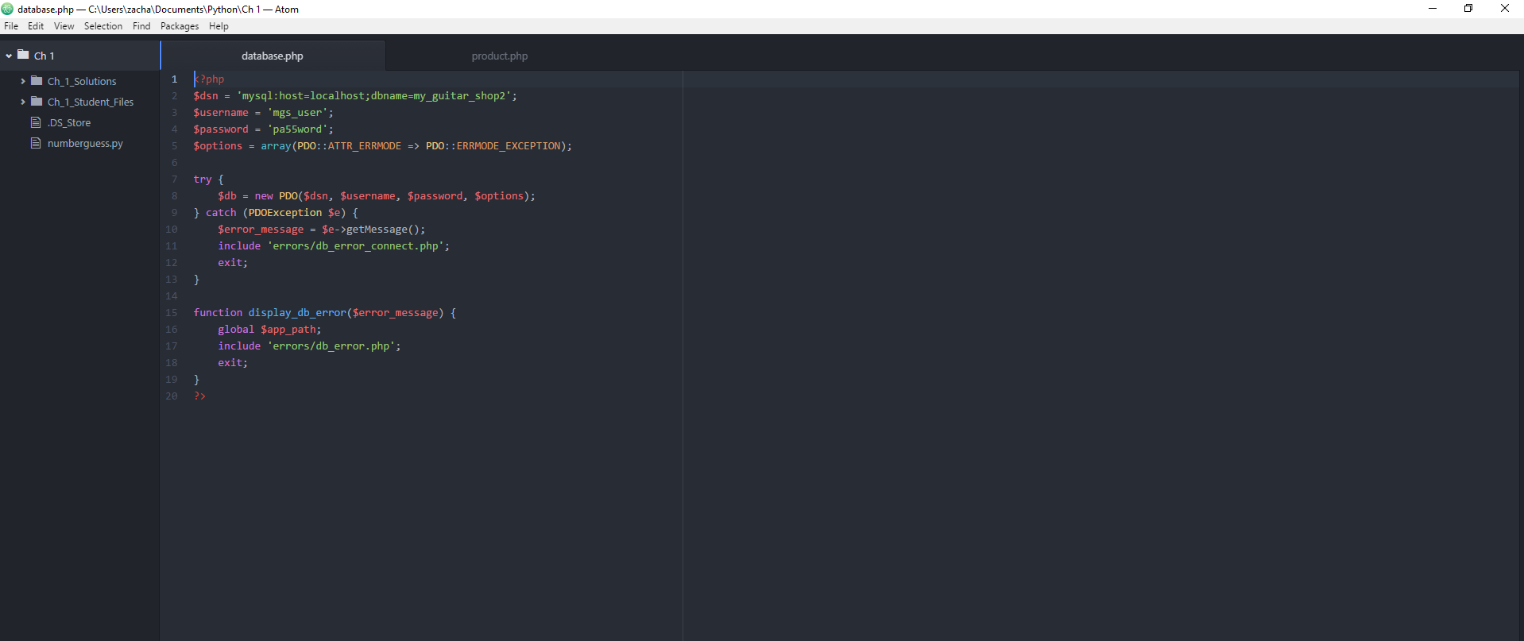Reviewing the code.*

**Ex 20-1 #5:**

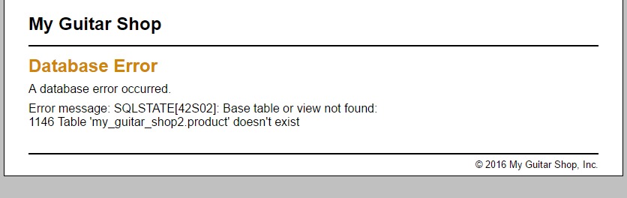

*Error produced when you change the table name from “products” to “product”.*

**Ex 20-1 #6:**

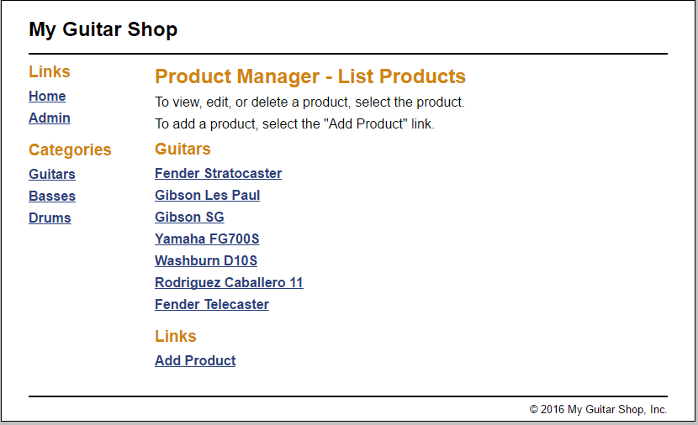

*Undoing what you did in step five obviously resoles the issue.*

**Ex 20-1 #7:**

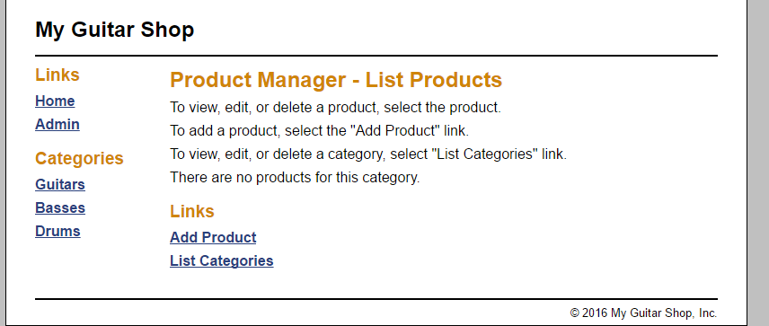

*Added the List Categories link to the Product Manager Admin Page.*

**Ex 20-1 # 8-12:**

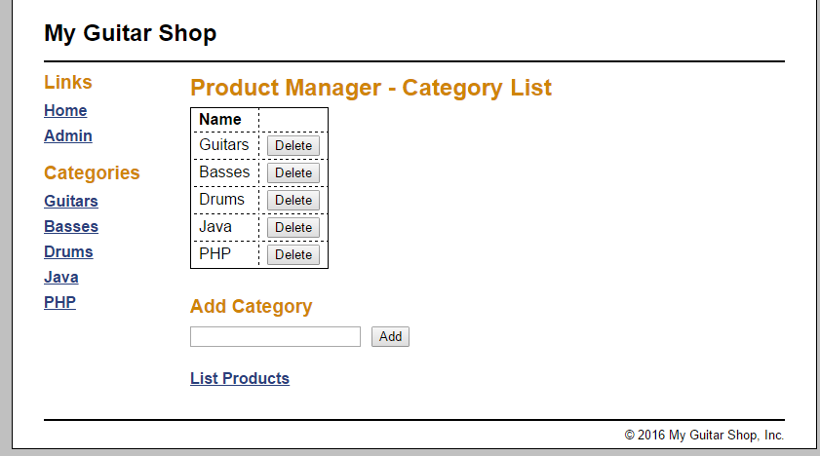

*Category List page successfully works, able to successfully add two categories.*

**Ex 20-1 # 13:**

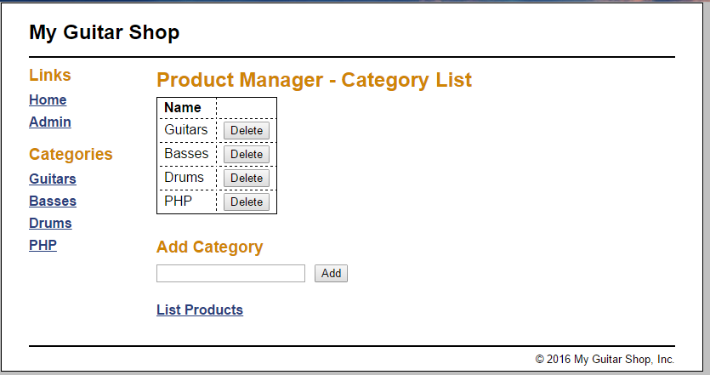

*I am also able to successfully delete one of the categories that I added.*

**Ex 20-1 #14:**



*Formatting on this page looks good enough.*

**Ex 20-1 #’s 15-17:**

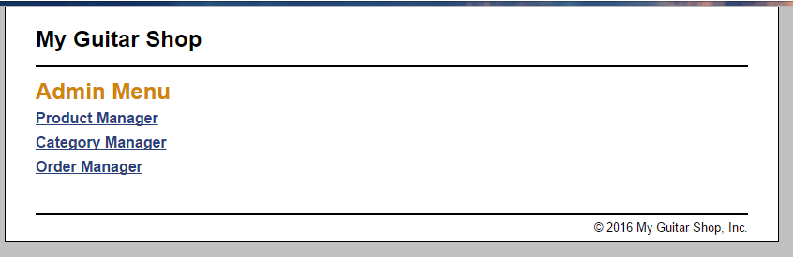

*Everything in this application works as it should.*